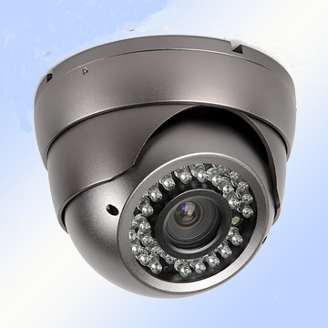
Detailed Product Description
Item No.:SAV-8011
1/3 SONY, 1/4 SHARP CCD is optional
420/480 TVL is optional
3.5" IR Vandalproof Dome Camera
3.5-9mm lens
36 pcs IR LED
30m IR Range
Color: Silver/ New Grey
Size:118x118x105mm
G.W.:0.9kg

